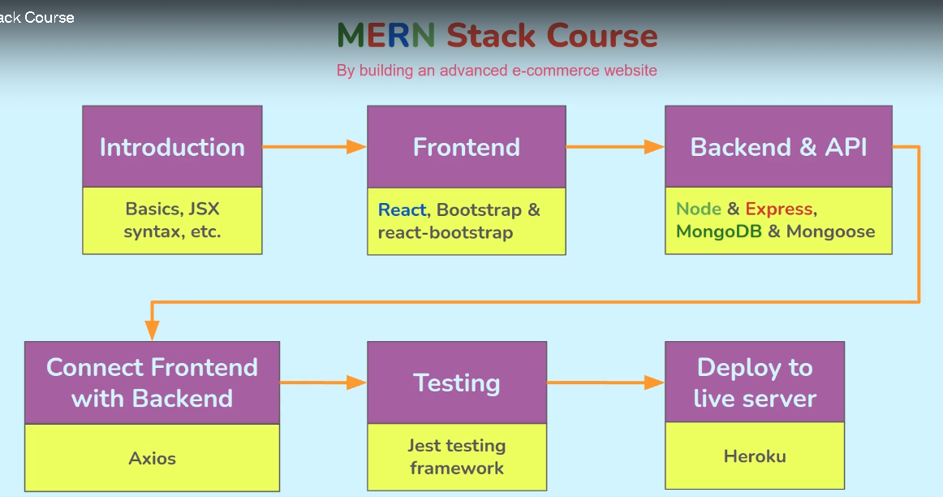

***JSX:-*** [***React JSX (w3schools.com)***](https://www.w3schools.com/react/react_jsx.asp)

***Keypoints: constant t=(<><p>Hello World!</>);***

***Use classname instead of class as class is a reserved name.***

***Elements must be closed***

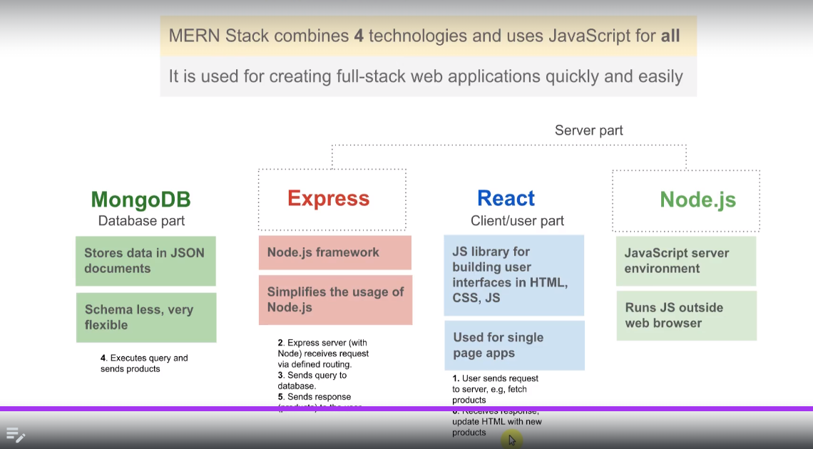

**Extension used in VScode: Quokka: It enables to perform javascript operations or sniplet inside console.**

**Press Ctrl+k and then press ‘L’ to select for a language in VScode.**

**Ctrl+Alt+F to format document**